**INTERACTIVE LEARNING CHAT APPLICATION SYSTEM**

**(Case study: Government Day Secondary School, Mubi)**

# TITLE PAGE

**BY**

**USAMA H IMAM**

**(ST/CS/HND/23/005)**

**DEPARTMENT OF COMPUTER SCIENCE,**

**SCHOOL OF SCIENCE AND TECHNOLOGY,**

**FEDERAL POLYTECHNIC, MUBI, ADAMAWA STATE.**

**IN PARTIAL FULFILLMENT OF THE REQUIREMENTS FOR THE AWARD OF HIGHER NATIONAL DIPLOMA (HND) IN COMPUTER SCIENCE.**

**JULY, 2025**

# DECLARATION

I hereby declare that the work in this project titled **“Interactive Learning Chat Application System (Case Study: Government Day Secondary School, Mubi)”** was performed by me under the supervision of Mrs. Aaron Catherine. The information derived from literatures has been duly acknowledged in the text and a list of references provided. The work embodied in this project is original and had not been submitted in part or in full for any other diploma or certificate of this or any other institution.

Usama H. Imam ________________ _______________

(ST/CS/HND/23/005) Signature Date

# CERTIFICATION

This project titled **“Interactive Learning Chat Application System (Case Study: Government Day Secondary School, Mubi)”** meets the regulations governing the award of Higher National Diploma (HND) in Computer Science, Federal Polytechnic Mubi, Adamawa State

Mrs. Aaron Catherine __________________

(Project Supervisor) Sign/Date

Mr. Kassim Mustapha __________________

(Head of Department) Sign/Date

Mal. Abdulrahman Saidu __________________

(External Examiner) Sign/Date

# DEDICATION

This project is dedicated to my lovely parents for her advice, encouragement and financial support towards my academic pursuit.

# ACKNOWLEDGEMENTS

I want to acknowledge Almighty God for his infinite mercy and protection throughout my academic activities. And for the understanding in achieving our academic success.

I appreciate my Supervisor Mrs. Aaron Catherine who took time despite her busy schedule to direct and guide me throughout this research work.

I also acknowledge the Head of Department Computer Science Mal. Kassim Mustapha for his moral encouragement throughout and all Staff of Computer Science Department for their support and encouragement and the knowledge they have impacted on me throughout my studies.

My appreciation goes to my lovely parent for their love and care and for giving me the opportunity to be trained and achieve my dreams.

Finally, I appreciate the efforts of my uncles and aunties, for their encouragement and support throughout the course of my study and also my friends and relatives, course mates and all well-wishers. I love you all, may the Almighty God bless you abundantly, Amen.

# TABLE OF CONTENTS

TITLE PAGE i

DECLARATION ii

CERTIFICATION iii

DEDICATION iv

ACKNOWLEDGEMENTS v

TABLE OF CONTENTS vi

LIST OF FIGURES viii

LIST OF TABLES ix

ABSTRACT x

CHAPTER ONE 1

INTRODUCTION 1

1.1 Background to the Study 1

1.2 Problem Statement 2

1.3 Aim and Objectives 3

1.4 Significance of the Study 3

1.5 Scope of the Study 3

1.6 Definition of some Operational Terms 4

**CHAPTER TWO 5**

**LITERATURE REVIEW 5**

2.1 Introduction 5

2.2 Collaborative Learning in Digital Education 5

2.3 Chat Applications for Learning 6

2.5 Interactive Tools in Learning Applications 8

2.6 Theoretical Framework 10

2.6.1 The Theory of Constructivism 10

2.6.2 The Theory of Collaborative Learning 10

2.7 Related Studies 11

2.8 Summary of Literature 13

CHAPTER THREE 14

SYSTEM ANALYSIS AND DESIGN 14

3.1 Introduction 14

3.2 Disadvantages of Existing System 14

3.3 Advantages of the Proposed System 14

3.4 Software Development Model 15

3.4.1 Waterfall Model 15

3.5 Methods of Data Collection 16

3.6 System Design 17

3.6.1 UML Algorithm 17

3.6.3 Database Tables/Queries Structures 19

3.6.4 Entity Relationship Model 20

3.6.4 The Input and Output Design 20

3.7 System Requirement Specification 22

3.7.1 Hardware Requirements 22

3.7.2 Software Requirements 22

CHAPTER FOUR 23

RESULTS AND DISCUSSION 23

4.1 Introduction 23

4.2 Results 23

4.3 Discussion 27

4.4 User manual 28

4.4.1 System Installation 28

4.4.2 System Operational Guide 28

CHAPTER FIVE 29

SUMMARY, CONCLUSION AND RECOMMENDATIONS 29

5.1 Summary 29

5.2 Conclusion 29

5.3 Recommendations 29

APPENDIX A 33

APPENDIX B 36

# LIST OF FIGURES

Figure 3.1: Waterfall Model - - - - - - - - 15

Figure 3.2: Use Case Diagram - - - - - - - 17

Figure 3.3: System Architecture - - - - - - - 18

Figure 3.4: Entity Relationship Model - - - - - - 19

Figure 3.5: Entity Relationship Model - - - - - - 20

Figure 3.6: Registration Form - - - - - - - 20

Figure 3.7: Output Registration Form - - - - - - 21

Figure 3.8: Chat Interface - - - - - - - - 21

Figure 3.9: Output Chat Interface - - - - - - - 21

Figure 4.1: Welcome Interface - - - - - - - 23

Figure 4.2: Add Student interface - - - - - - - 24

Figure 4.3: Login page interface - - - - - - - 24

Figure 4.4: Available Users Interface - - - - - - - 25

Figure 4.5: Learning Mode chat interface - - - - - - 26

# LIST OF TABLES

Table 3.1: Users - - - - - - - - - 19

Table 3.2: Messages - - - - - - - - - 19

# ****ABSTRACT****

*This project presents the design and implementation of a Collaborative Learning Chat Application with Interactive Tools aimed at enhancing student engagement, communication, and teamwork in an academic environment. Traditional learning methods often lack real-time interaction, collaboration, and access to dynamic learning tools. This system was developed to bridge these gaps by providing a platform where students and instructors can communicate through chat, share resources, and collaborate effectively using integrated features such as whiteboards, quizzes, and document sharing tools. The system was designed using web technologies including HTML, CSS, JavaScript, PHP, and MySQL for the backend database. Key features include user registration and login, real-time messaging, user presence tracking, and interactive tools that support synchronous learning. The application also includes a dedicated learning mode chat interface for focused academic conversations and an available user’s interface to display active participants. This project demonstrates how technology can foster a more interactive and collaborative learning experience. It offers an efficient way to track student participation and progress, improve accessibility to learning materials, and encourage teamwork in both remote and blended learning environments. The system was successfully tested and validated to ensure that it meets the goals of promoting collaborative and interactive learning, particularly in educational institutions looking to adopt digital transformation in their instructional methods.*

*.*

# CHAPTER ONE

# INTRODUCTION

**1.1 Background to the Study**

Collaboration in learning has become an essential aspect of modern education and professional training. With advancements in technology, digital platforms now offer interactive tools that enhance learning experiences, making knowledge acquisition more efficient and engaging. A Collaborative Learning Chat Application with interactive tools aims to provide a dynamic and interactive environment where users can exchange knowledge, engage in discussions, and collaborate on projects in real time (Oliver, 2024). Traditional learning methods often involve face-to-face discussions, group assignments, and classroom interactions. However, these methods can be limited by factors such as geographical distance, availability of resources, and time constraints. The development of a collaborative learning chat application addresses these limitations by providing a digital platform where students, teachers, and professionals can interact, share ideas, and work together seamlessly. With the integration of interactive tools such as file sharing, real-time document collaboration, quizzes, video calls, and AI-powered assistance, this application enhances user engagement and fosters an inclusive learning environment. By leveraging cloud-based technologies and artificial intelligence, the application can provide personalized learning experiences, improve communication efficiency, and enable users to access educational resources anytime and anywhere (Xu & Ouyang, 2022).

Recent advancements in technology have led to the development of various collaborative learning applications that provide real-time interaction among learners. Platforms such as Google Classroom, Microsoft Teams, and Zoom have integrated collaborative tools like shared whiteboards, breakout rooms, and interactive quizzes to enhance engagement (Brown & Green, 2022). These tools enable learners to actively participate in discussions, receive instant feedback, and develop critical thinking skills. However, despite these improvements, challenges such as lack of engagement, ineffective communication, and difficulty in tracking individual contributions persist in many existing platforms (Kim, 2023). Artificial intelligence is playing a crucial role in enhancing collaborative learning experiences. AI-powered chatbots and virtual tutors can provide real-time assistance, answer questions, and suggest relevant resources based on learners' needs (Hwang, 2023).

Another major trend in collaborative learning is the use of gamification techniques to increase student motivation and engagement. Gamified learning environments integrate elements such as leaderboards, badges, and reward systems to encourage participation and improve learning outcomes (Dicheva *et al.,* 2022). Research has shown that students who engage in gamified collaborative learning activities demonstrate higher levels of engagement and knowledge retention compared to those using traditional learning methods (Hamari *et al.,* 2021). The integration of gamification in the Collaborative Learning Chat Application will ensure a more interactive and enjoyable learning experience. Moreover, immersive technologies such as Virtual Reality (VR) and Augmented Reality (AR) have revolutionized collaborative learning by providing realistic and interactive simulations. For example, platforms like Mozilla Hubs and Engage VR allow students to work together in virtual environments, simulating real-world scenarios such as medical training, historical explorations, and scientific experiments (López *et al.,* 2023).

Incorporating AI into collaborative learning also addresses challenges such as unequal participation and difficulty in assessing individual contributions. AI tools can monitor group interactions, analyze participation levels, and provide insights to ensure balanced involvement. They can also assist in peer and self-assessment processes by offering rubrics and personalized reflection prompts, leading to more accurate and fair evaluations. As AI continues to evolve, its role in collaborative learning is expected to expand further. Future applications may include emotion-aware group dynamics, where AI detects and responds to the emotional states of group members to improve collaboration, and augmented reality environments that provide immersive, hands-on collaborative experiences. These advancements hold the potential to create more engaging, equitable, and effective collaborative learning environments, preparing students for the complex, interconnected challenges of the 21st century (Anderson & Dron, 2021).

**1.2 Problem Statement**

Despite the growing adoption of digital learning platforms, many existing applications lack effective real-time collaboration tools that cater to both students and educators. Most chat applications focus on communication rather than interactive learning, leading to challenges such as:

1. Lack of real-time document collaboration, which limits group productivity.
2. Inability to integrate multimedia resources such as videos, images, and interactive quizzes.
3. Absence of AI-driven features that provide recommendations and automated assistance.
4. Difficulty in tracking learning progress and engagement within group discussions.

To address these challenges, the development of a Collaborative Learning Chat Application with interactive tools is essential. This application aims to create a dynamic and user-friendly environment where learners can interact through text, voice, and video chat while accessing various collaborative features such as document co-editing, brainstorming boards, and AI-powered study assistants.

**1.3 Aim and Objectives**

The aim of this study is to design and implement a Collaborative Learning Chat Application with Interactive Tools. The specific objectives are:

1. To design a chat-based platform that supports real-time messaging and group discussions using UML
2. To implement the designed system using PHP, MySQL and HTML/CSS.
3. To test the system for functionality and usuability.

**1.4 Significance of the Study**

This study holds significant importance for various stakeholders in the education and technology sectors. For students and educators, the proposed collaborative learning chat application offers a highly efficient and interactive platform for group discussions, assignments, and project-based learning. Traditional online communication tools often lack the necessary features for dynamic and engaging collaboration, leading to ineffective teamwork and communication barriers. Educational institutions also stand to benefit from the implementation of this system, particularly in managing remote and hybrid learning environments. The COVID-19 pandemic highlighted the challenges of online education, revealing gaps in communication, engagement, and assessment. This application addresses these issues by providing an intuitive and structured platform for virtual learning. Institutions can utilize the system to streamline coursework, foster student engagement, and ensure that learning continues effectively regardless of geographical constraints.

**1.5 Scope of the Study**

This study focuses on the development of a Collaborative Learning Chat Application equipped with essential features. The application will include real-time chat where users can engage in meaningful academic conversations, exchange ideas, and collaborate on projects. Additionally, it will incorporate interactive tools such as file sharing, and quizzes to promote active learning. The primary target users of this application include students, educators, and professionals who require an efficient and structured environment for collaborative learning.

**1.6 Definition of some Operational Terms**

**Application:** A software program designed to perform specific tasks or functions for users

**Chat Application:** A software platform that allows users to communicate in real time via text, voice, or video.

**Collaborative Learning:** A learning approach where individuals work together to achieve common educational goals.

**Interactive Tools:** Digital features such as quizzes, document collaboration, and multimedia sharing that enhance engagement.

**Learning:** A cognitive process through which individuals acquire knowledge, skills, attitudes, or values through study, experience, or teaching.

**System:** A structured set of components or processes working together to achieve a specific goal.

## ****CHAPTER TWO****

## ****LITERATURE REVIEW****

### ****2.1 Introduction****

This chapter reviews existing literature related to collaborative learning environments, the use of chat applications in educational settings, and the development of interactive tools that support student engagement and group collaboration. It explores the theoretical foundations of collaborative learning, the evolution of educational communication tools, and the current state of technological advancements in educational software. The review also examines similar systems, their features, strengths and research gap.

### 2.2 Collaborative Learning in Digital Education

Collaborative learning is an instructional approach in which learners work collectively toward shared academic objectives, promoting not only knowledge acquisition but also critical thinking, problem-solving skills, and teamwork (Dillenbourg, 2019). This pedagogical strategy is based on the social constructivist theory, which emphasizes that learning is most effective when individuals interact and construct knowledge together rather than in isolation (Vygotsky, 1978). Traditionally, collaborative learning occurred in face-to-face settings, such as group discussions, peer reviews, and cooperative problem-solving exercises. However, with advancements in digital technology, collaborative learning has increasingly transitioned into virtual environments, where online platforms facilitate real-time communication, document co-editing, and interactive discussions (Hrastinski, 2021).

The integration of digital tools into collaborative learning has significantly enhanced its effectiveness by providing flexible, interactive, and accessible environments for learners. Digital platforms enable students to engage in meaningful discussions, share resources, and co-develop knowledge regardless of their physical location. Research indicates that students participating in online collaborative learning environments exhibit higher motivation levels, deeper cognitive engagement, and improved knowledge retention compared to traditional lecture-based instruction (Tang *et al.,* 2020). Furthermore, digital collaboration fosters inclusivity, allowing students with diverse backgrounds and learning styles to contribute equally in an interactive setting (Järvelä *et al.,* 2021).

The importance of collaborative digital learning has been further highlighted by the increasing adoption of online and blended learning models, particularly in response to global challenges such as the COVID-19 pandemic. During this period, educational institutions worldwide rapidly implemented digital collaboration tools like Microsoft Teams, Google Classroom, Zoom, and Slack to facilitate remote teaching and learning (Basilaia & Kvavadze, 2020). These platforms provided essential features such as virtual breakout rooms, shared document editing, and instant messaging, which enabled students and instructors to maintain real-time engagement and peer-to-peer interactions despite geographical constraints (Crompton *et al.,* 2021).

Moreover, the effectiveness of collaborative learning in digital education extends beyond formal classroom settings. Many professional training programs, corporate learning environments, and online certification courses incorporate collaborative elements to enhance engagement and knowledge co-construction among learners (Bernard *et al.,* 2022). Studies show that when learners work together using digital tools, they develop a sense of accountability, active participation, and deeper understanding of the subject matter (Rosé *et al.,* 2019). This underscores the significance of well-designed collaborative learning applications that integrate interactive tools, fostering both academic achievement and essential soft skills such as communication, leadership, and teamwork.

As digital education continues to evolve, the role of collaborative learning platforms will become increasingly vital in bridging gaps between remote and in-person learning experiences. Future advancements in artificial intelligence (AI) and adaptive learning technologies may further refine the effectiveness of collaborative digital learning by offering personalized recommendations, intelligent feedback, and data-driven insights into student progress (Luckin *et al.,* 2021). By leveraging these innovations, collaborative learning in digital education can continue to enhance learning outcomes and prepare students for the dynamic and interconnected world of the 21st century.

### 2.3 Chat Applications for Learning

Chat applications are interactive software platforms that facilitate real-time communication through text, voice, or video, enabling seamless interaction among users. These applications have become increasingly integral to education, providing a structured yet flexible medium for students and instructors to engage in discussions, share resources, and collaborate on academic tasks (Rosell-Aguilar, 2022). Unlike traditional classroom settings, where communication is often limited to scheduled sessions, chat-based learning environments offer continuous, asynchronous, and synchronous interactions, allowing learners to seek clarification, participate in discussions, and receive feedback at any time (Sharma & Kitchens, 2021). This level of accessibility makes chat applications particularly valuable in online and blended learning models, where students require alternative ways to connect with peers and educators.

One of the key benefits of chat applications in learning environments is their ability to foster instant feedback and discussion-based problem-solving. According to Sharma and Kitchens (2021), real-time messaging platforms create an interactive learning ecosystem where students can collaboratively construct knowledge, critically analyze concepts, and enhance their understanding through peer discussions. The immediacy of responses in chat applications also plays a crucial role in maintaining student engagement, reducing response delays often encountered in email-based or forum discussions. Furthermore, chat applications encourage informal learning, as students can communicate in a more relaxed setting, enhancing their willingness to participate and ask questions without the constraints of traditional classroom dynamics (Hrastinski, 2021).

Modern advancements in artificial intelligence (AI) and machine learning (ML) have further transformed chat applications into intelligent learning assistants. AI-driven chatbots, virtual tutors, and recommendation systems embedded within these platforms enhance learning experiences by offering personalized guidance, answering queries, and suggesting relevant educational materials (Zawacki-Richter *et al.,* 2019). These AI-powered systems analyze user behavior, learning patterns, and engagement levels to provide customized content, thereby addressing individual learning needs more effectively than conventional static resources. Research by Xu *et al.* (2020) highlights that AI-enhanced chatbots in education significantly improve student motivation and engagement by offering immediate responses, adaptive learning support, and automated assessments that track academic progress.

Moreover, chat applications integrated with intelligent learning tools can simulate interactive classroom experiences, bridging the gap between physical and digital learning spaces. Features such as threaded discussions, multimedia sharing, and collaborative document editing allow students to engage in deep learning experiences beyond simple text-based conversations. Additionally, voice and video chat functionalities enhance the sense of presence in virtual classrooms, facilitating group discussions, mentoring sessions, and collaborative assignments in a manner similar to in-person interactions (Bernard *et al.,* 2022). These features make chat applications an indispensable component of modern education, particularly in distance learning and remote education scenarios.

As education continues to evolve in response to technological advancements and changing learning needs, chat applications are expected to play an even more prominent role in facilitating interactive and student-centered learning environments. Future developments in AI, natural language processing (NLP), and adaptive learning technologies may further refine chat applications, making them even more intuitive, responsive, and capable of providing real-time personalized learning experiences. By leveraging these advancements, educational institutions and e-learning platforms can continue to enhance collaborative learning, foster engagement, and support diverse learning preferences in the digital age (Luckin *et al.,* 2021).

### 2.5 Interactive Tools in Learning Applications

Interactive tools play a crucial role in enhancing the effectiveness of online learning by incorporating engaging digital elements that foster active participation, collaboration, and knowledge retention. These tools go beyond passive content delivery by allowing learners to interact with the material, instructors, and peers in dynamic and meaningful ways (Hew et al., 2020). By integrating features such as quizzes, polls, shared whiteboards, and collaborative document editing, learning applications create immersive educational experiences that improve comprehension and facilitate deeper engagement with the subject matter. Interactive tools also support different learning styles, ensuring that students with diverse preferences such as visual, auditory, or kinesthetic learners—can effectively grasp concepts through various mediums (Mayer, 2021).

Several interactive tools have gained prominence in digital education due to their ability to improve the learning process and create a more engaging environment. These include:

1. **Quizzes and Assessments:** Interactive quizzes serve as essential tools for assessing student understanding, reinforcing learning, and providing immediate feedback. Unlike traditional assessments, which may involve long waiting periods for results, digital quizzes offer instant responses, allowing learners to identify knowledge gaps and correct misconceptions in real time (Chiang *et al.,* 2021). Adaptive quizzes, which modify question difficulty based on user responses, further enhance the learning experience by challenging students at their appropriate competency level. Platforms such as Kahoot!, Quizizz, and Google Forms have revolutionized online assessments by making them more interactive, competitive, and engaging, thereby increasing learner motivation and participation.
2. **Collaborative Editing:** Collaborative document editing tools, such as Google Docs, Microsoft OneNote, and Notion, enable multiple users to work on the same document simultaneously, fostering teamwork and collective knowledge-building (Westera, 2020). These tools allow real-time commenting, suggesting edits, and tracking revision history, making them particularly valuable for group projects, peer reviews, and instructor-student interactions. The ability to collaborate asynchronously also means that learners from different time zones or schedules can contribute effectively, enhancing inclusivity and flexibility in online learning. Such tools support constructivist learning principles, where students actively construct knowledge by engaging in discussions, sharing ideas, and refining their understanding through peer collaboration.
3. **Multimedia Sharing:** The integration of multimedia elements such as videos, images, audio notes, and animations expands the ways in which information is presented, catering to various learning preferences and improving content retention. Research has shown that multimedia-based instruction enhances cognitive processing by combining verbal and visual elements, which helps students understand complex concepts more effectively (Mayer, 2021). Platforms like Edpuzzle, Flipgrid, and YouTube for Education enable educators to create interactive video lessons that include embedded questions, discussions, and explanatory visuals. Furthermore, screen recording and annotation tools allow instructors to provide personalized feedback, guiding students through problem-solving processes with step-by-step visual explanations.
4. **Gamification Elements:** Gamification has emerged as a powerful educational strategy that incorporates game-like features, such as points, badges, leaderboards, and achievement levels, to boost student motivation and engagement. By introducing elements of competition and reward, gamified learning applications encourage active participation, persistence, and goal-oriented learning behaviors (Dicheva *et al.,* 2018). Platforms such as Duolingo, Classcraft, and Kahoot! effectively use gamification to transform learning into an interactive and enjoyable experience. Research suggests that gamification not only increases student engagement but also enhances retention and application of knowledge by promoting repeated practice and reinforcing positive learning behaviors (Hamari *et al*., 2019).

Overall, interactive tools in learning applications provide an enriched digital learning environment that fosters engagement, enhances collaboration, and personalizes the educational experience. As technology continues to evolve, future advancements in artificial intelligence (AI), augmented reality (AR), and virtual reality (VR) are expected to further transform interactive learning, making it even more immersive, adaptive, and effective in catering to the diverse needs of learners (Luckin *et al.,* 2021).

### ****2.6 Theoretical Framework****

## 2.6.1 The Theory of Constructivism

Constructivism, initially proposed by the Swiss psychologist Jean Piaget, is a theory that describes how learning occurs and how knowledge is constructed through interactions with prior knowledge (Piaget, 1952). Constructivism emphasizes the active role of learners in the learning process, contrasting with traditional educational models where the instructor assumes full responsibility for knowledge transmission (Schunk, 2020).

Lev Vygotsky’s (1978) sociocultural perspective further refined constructivism by introducing the concept of collaborative elaboration, wherein knowledge is first constructed through social interactions before being internalized by individuals. Vygotsky posited that the process of sharing perspectives enhances understanding beyond what learners could achieve independently (Kozulin, 2003). Constructivism highlights three key principles: (1) learning as an active process wherein learners independently discover concepts and principles, (2) the instructor serving as a facilitator, mentor, and coach rather than a direct provider of information, and (3) knowledge being constructed rather than instructed, emphasizing interaction, discussion, and collaboration in a social context (Mayer, 2021).

## 2.6.2 The Theory of Collaborative Learning

Collaborative learning is a pedagogical approach where learners at different levels work together to solve problems, complete tasks, or create shared products (Dillenbourg, 1999). It is grounded in the premise that learning is inherently social, with knowledge being co-constructed through active dialogue and interaction (Slavin, 2019). In collaborative learning, students take responsibility for each other’s learning while engaging in meaningful discussions (Gillies, 2016).

Effective collaborative learning is characterized by positive interdependence, individual accountability, interpersonal skills, promotive interaction, and collective processing (Johnson & Johnson, 2021). Research indicates that students in collaborative settings retain more information and develop more positive attitudes toward learning compared to those who work individually (Kirschner et al., 2018). The instructor’s role in collaborative learning includes forming effective groups, facilitating discussions, suggesting alternatives, and providing feedback, rather than imposing solutions (Panitz, 2021). Collaborative learning, with or without technology, fosters critical thinking, problem-solving, and increased engagement among learners (Barkley et al., 2022).

**2.6.3 The Theory of Mobile Learning**

Mobile learning (m-learning) leverages mobile technologies such as smartphones, tablets, and laptops to provide learners with flexible, accessible, and interactive educational experiences (Traxler, 2020). M-learning emphasizes the mobility of learners and their ability to interact with digital content anytime and anywhere (Crompton, 2017). This immediacy facilitates instant feedback and peer collaboration, enhancing learning experiences (Sharples *et al.,* 2019).

The rise of 4G/5G wireless connectivity has further expanded the scope of mobile learning, allowing for seamless access to digital educational resources (Alrasheedi & Capretz, 2021). According to Jacobs (2013), “always-on, always-connected mobile devices have the potential to dramatically improve educational outcomes.” Mobile learning supports student-centered learning, promotes group collaboration, and utilizes interactive features such as communication apps and video-based content to enhance engagement (Khaddage *et al.,* 2016). Recent research underscores that mobile learning can improve academic performance, particularly in informal learning environments (West, 2022).

## ****2.7 Related Studies****

Numerous studies have explored the role of interactive tools in digital learning environments and their impact on student engagement, collaboration, and knowledge retention. Hew *et al.* (2020) found that interactive learning technologies, such as quizzes and discussion forums, significantly enhanced student participation and comprehension in online courses. Similarly, Chiang *et al.* (2021) examined the effects of real-time quizzes on student performance and discovered that learners who engaged with interactive assessments retained information better and performed higher on final exams. Mayer (2021) emphasized the importance of multimedia integration in education, revealing that students who received information through a combination of text, visuals, and audio exhibited improved cognitive processing and understanding of complex concepts.

In a study on collaborative learning, Westera (2020) highlighted that online collaborative tools like Google Docs and Microsoft OneNote foster teamwork and peer learning, improving students’ ability to co-construct knowledge. Additionally, Sharma and Kitchens (2021) investigated chat-based learning environments and found that instant messaging applications facilitated real-time discussions, allowing students to clarify doubts quickly and engage in deeper discussions with peers and instructors. Xu *et al.* (2020) further explored the use of intelligent chatbots in education, demonstrating that AI-driven chat systems provided personalized learning support, thereby increasing student motivation and engagement.

Gamification has also been widely studied as an interactive learning strategy. Dicheva *et al.* (2018) found that incorporating game-based elements, such as leaderboards and achievement badges, led to increased motivation and active participation among students. Hamari *et al.* (2019) expanded on this by showing that gamification not only improved engagement but also encouraged repeated practice, reinforcing learning outcomes. Luckin *et al.* (2021) examined the potential of artificial intelligence in interactive learning, concluding that AI-powered adaptive learning systems significantly improved student performance by tailoring educational content to individual learning styles.

The effectiveness of multimedia sharing tools was analyzed by Rosell-Aguilar (2022), who found that incorporating video-based content, interactive simulations, and virtual experiments enhanced students’ problem-solving skills and conceptual understanding. Basilaia and Kvavadze (2020) studied the impact of digital collaboration tools during the COVID-19 pandemic and noted that platforms such as Zoom, Microsoft Teams, and Google Classroom played a critical role in maintaining student engagement and facilitating remote learning. Tang *et al.* (2020) supported this finding, demonstrating that students in digital collaborative learning environments showed higher motivation and knowledge retention compared to those using traditional learning methods.

Research by Zawacki-Richter *et al.* (2019) explored the integration of artificial intelligence in online learning, revealing that AI-powered recommendation systems effectively guided students toward relevant learning materials, improving the overall learning experience. Hrastinski (2021) examined the role of real-time communication in digital education, showing that synchronous learning tools, such as live video discussions and virtual whiteboards, increased student interaction and engagement. Lastly, a study by Dillenbourg (2019) concluded that digital collaborative learning significantly enhances critical thinking skills, as students actively participate in knowledge construction and peer discussions.

Further research by Kizilcec *et al.* (2020) examined the impact of adaptive learning technologies on student outcomes, showing that AI-driven personalization in digital education led to better comprehension and retention rates. Their study emphasized how machine learning algorithms tailor learning experiences to individual needs, allowing students to progress at their own pace. Similarly, Park and Kim (2021) investigated the role of augmented reality (AR) in education, finding that interactive AR-based learning applications increased engagement and deepened students’ understanding of complex scientific concepts through immersive experiences.

In the realm of peer collaboration, Sun *et al.* (2021) explored the use of virtual whiteboards and annotation tools, concluding that these interactive features facilitated knowledge-sharing and enhanced problem-solving skills. Their study found that students using collaborative annotation tools performed better in group-based assessments than those relying on static learning materials. Additionally, Azevedo *et al.* (2022) conducted a meta-analysis of self-regulated learning in digital environments, demonstrating that interactive tools such as progress trackers and AI-based tutoring systems improved student autonomy and learning outcomes.

## ****2.8 Summary of Literature****

This chapter has provided a comprehensive review of the theoretical foundations and key principles underlying digital education, focusing on constructivism, collaborative learning, and mobile learning. These theories emphasize the importance of active engagement, peer interaction, and technology integration in modern learning environments. The discussion has also explored collaborative learning principles, demonstrating how digital platforms facilitate teamwork, knowledge-sharing, and problem-solving through structured communication and interactive tools. Despite the extensive benefits of chat-based collaborative learning, several research gaps and limitations exist in current digital learning systems. Many studies have focused on the general advantages of chat applications in education, yet there remains a lack of empirical research on their long-term impact on student performance and engagement across diverse learning environments. Addressing these research gaps will be essential in the development of a more efficient, secure, and accessible chat-based collaborative learning system. To address these challenges, the development of a Collaborative Learning Chat Application with interactive tools is essential.

# CHAPTER THREE SYSTEM ANALYSIS AND DESIGN

## 3.1 Introduction

This chapter contains the system design, the disadvantages of the existing system, the advantages of the proposed system over the existing system, the system requirements (Hardware and Software), the design and the system architecture.

### ****3.2 Disadvantages of Existing System****

Traditional learning methods pose several challenges that hinder effective collaboration and engagement among students.

1. Traditional methods rely heavily on static materials like textbooks and lectures, which do not support dynamic, real-time collaboration between students and educators.
2. There are limited tools to monitor individual contributions, engagement levels, and learning progress in real time.
3. Educators face challenges in providing instant feedback or assessing performance during the learning process.
4. Students often face difficulties in organizing, accessing, and sharing learning materials efficiently.
5. Communication is usually confined to classroom hours, making it difficult for students to collaborate outside of scheduled sessions.
6. Traditional learning does not integrate digital tools such as shared whiteboards, live quizzes, collaborative documents, or real-time chat, which are crucial for modern, engaging learning experiences.

### ****3.3 Advantages of the Proposed System****

The **Collaborative Learning Chat Application with Interactive Tools** will provide the following benefits over traditional learning methods:

1. **Enhanced Real-Time Interaction and Engagement**
2. **Seamless Communication Between Students and Educators**
3. **Interactive Learning Tools, such as Whiteboards and Quizzes**
4. **Efficient Progress Tracking and Participation Monitoring**
5. **Secure and Organized Resource Sharing**
6. **Automated Notifications and Scheduling**
7. **Personalized Learning Experience and Customization**
8. **Data-Driven Insights for Continuous Improvement**
9. **User-Friendly Interface for Easy Adoption**

### ****3.4 Software Development Model****

## ****3.4.1 Waterfall Model****

The development of the **Collaborative Learning Chat Application with Interactive Tools** will follow the **Waterfall Model,** ensuring a structured and systematic approach to implementation. The system will progress through distinct phases, illustrated in Figure 3.1, to ensure accuracy, reliability, and effectiveness in collaborative learning environments.

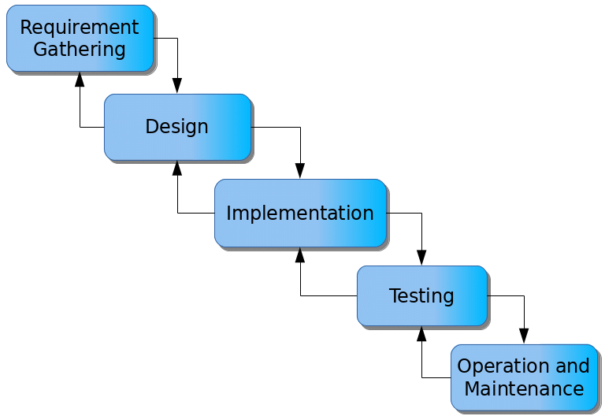

Figure 3.1: Waterfall model

**3.4.1.1 Requirements Gathering**

1. Project stakeholders, including students, staff, and event organizers, will be engaged to collect comprehensive information about event planning, scheduling, and management needs.
2. Specific requirements for user roles, event categories, and notification methods will be documented.
3. All gathered requirements will be meticulously recorded for reference throughout the system development process.

**3.4.1.2 System Design**

1. The system architecture will be developed, outlining the decision-making process and workflow for event management.
2. A database schema will be designed to store and retrieve event details, user profiles, and notifications efficiently.
3. A user-friendly interface will be created to allow organizers to add events, students to register for events, and administrators to oversee activities.

**3.4.1.3 Implementation**

1. The system design specifications will be translated into a functional web-based or mobile application, adhering to best practices in event management.
2. A notification system will be implemented to send real-time updates via email, SMS, or in-app alerts.
3. The database structure will be developed to ensure secure and efficient storage of event data and user information.

**3.4.1.4 Testing**

1. Unit testing will be conducted to validate the accuracy and functionality of individual system components.
2. Integration testing will be performed to verify the smooth interaction between various modules and databases.
3. System testing will be carried out to assess the overall performance, reliability, and user experience of the system.

**3.4.1.5 Maintenance**

1. Identified issues or system bugs will be promptly addressed based on user feedback and performance reviews.
2. Regular updates will be implemented to incorporate new features and improve system efficiency.
3. Future enhancements will be planned to ensure the system remains relevant to evolving campus event management needs.

By following this structured approach, the Campus Event Management System will streamline event planning, enhance user engagement, and improve overall event management on campus.

## 3.5 Methods of Data Collection

There are two main sources of data collection in carrying out this study, information was basically obtained from the two sources which are primary and secondary sources.

**Primary Source:** Primary source of data that will be used in this study will be personal interview and observation.

**Secondary Source:** The secondary data used in the study will be obtained from magazines, Journal, newspapers, library source and most of the information from the library research has been covered in my literature review in the previous chapter of this project.

## 3.6 System Design

## 3.6.1 UML Algorithm

**3.6.1.1 Use case diagram**

A use case diagram at its simplest is a representation of a user’s interaction with the system and depicting the specifications of a use case. A use case diagram shows the system and the various ways that they interact with the sub system.

**CHAT APPLICATION**

Register

Send Message

View Events

User

Login

Read Message

Logout

Figure 3.2: Use Case Diagram

**3.6.1.2 Activity Diagram**

An activity diagram shows a flow of control in a system similar to a flowchart or a data flow diagram.

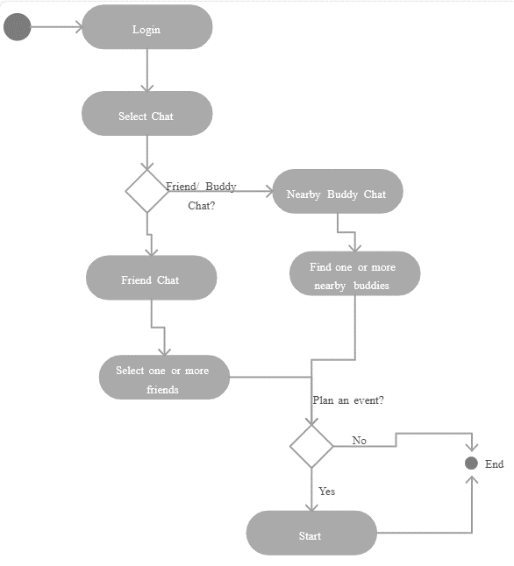

Figure 3.3: Activity diagram of the system

**3.6.2 System Architecture**

Database MySQL

Apache Server

**COLLABORATIVE CHAT APPLICATION**



Figure 3.4: System Architecture

## 3.6.3 Database Tables/Queries Structures

**Table 3.2****: User Table**

Top of Form

| **Name** | **Type** | **Null** | **Extra** |
| --- | --- | --- | --- |
| user_id Primary | int(11) | No | AUTO_INCREMENT |
| unique_id | int(255) | No |  |
| fname | varchar(255) | No |  |
| lname | varchar(255) | No |  |
| email | varchar(255) | No |  |
| password | varchar(255) | No |  |
| img | varchar(255) | No |  |
| status | varchar(255) | No |  |

Bottom of Form

**Table 3.2: Table messages**

| Name | Type | Null | Extra |
| --- | --- | --- | --- |
| msg_id Primary | int(11) | No | AUTO_INCREMENT |
| incoming_msg_id | int(255) | No |  |
| outgoing_msg_id | int(255) | No |  |
| msg | varchar(1000) | No |  |

## 3.6.4 Entity Relationship Model

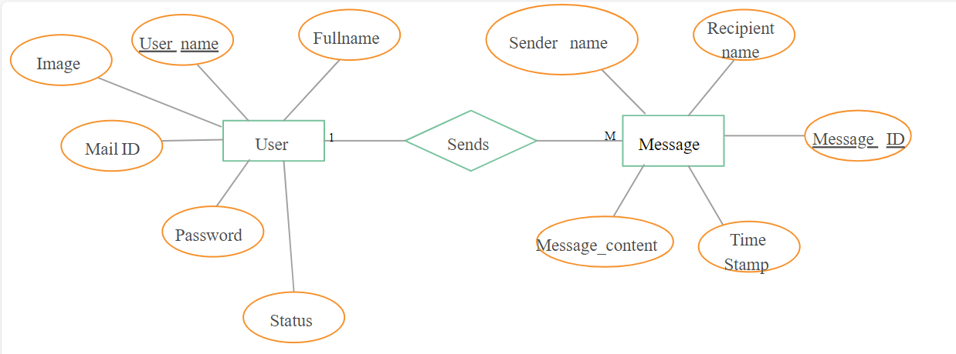

Figure 3.5: Entity Relationship Model

## 3.6.4 The Input and Output Design

**REGISTRATION**

Name

Sex

**CREATE ACCOUNT**

User name

Date of Birth

Phone Number

Email

Figure 3.6: Registration Form

**REGISTRATION FORM**

Usama Haruna

Male

**CREATE ACCOUNT Student**

Usamah

12/04/2002

08123324421

usama23@gmail.com

Figure 3.7: Output Registration Form

**CHAT INTERFACE**

Enter message here

**SEND MESSAGE Student**

Figure 3.8: Chat Interface

**CHAT INTERFACE**

How are you doing

**SEND MESSAGE Student**

Figure 3.9: Output Chat Interface

## 3.7 System Requirement Specification

## 3.7.1 Hardware Requirements

The software to be designed will need the following hardware for an effective operation.

1. A system running on intel, P(R) duo core with higher processor
2. The-Random Access Memory (RAM) should be at least 512MB.
3. At least 20-GB hard disk.
4. A colored monitor.
5. A mobile device.

## 3.7.2 Software Requirements

The software requirements include:

1. A window 7 or higher version of operating system.
2. XAMP or WAMP for Database
3. PHP
4. MySQL
5. Web browser

**3.7.3 Personnel Requirements**

The system will be design in such a way that it is user friendly in other to be understood and used by anyone with basic computer knowledge.

# CHAPTER FOUR

# RESULTS AND DISCUSSION

## 4.1 Introduction

This chapter presents the implementation and testing of the developed Collaborative Learning Chat Application with Interactive Tools. It outlines the steps taken to translate the system design into a working software solution, discusses the programming languages and tools used, explains how various components of the system were integrated, and describes the testing procedures employed to validate system functionality, performance, and usability.

## 4.2 Results

**4.2.1 Home page interface**

This is the first interface that users will encounter upon accessing the system. The Home Page Interface of a Collaborative learning chat application with interactive tools showing the project title and the researcher details.

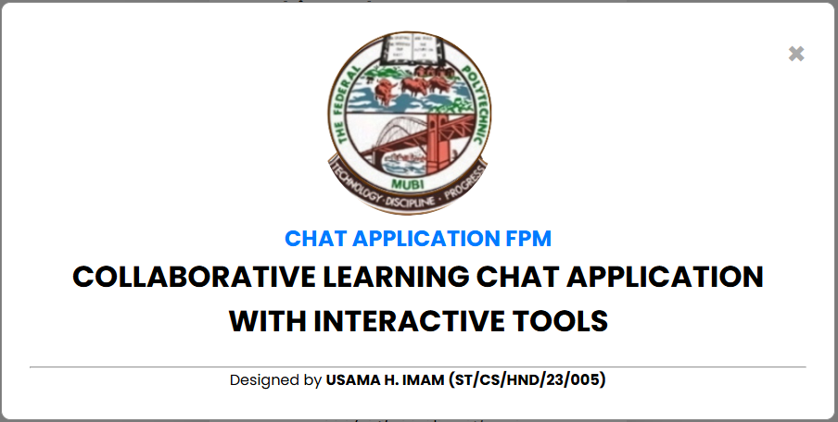

**INTERACTIVE LEARNING CHAT APPLICATION SYSTEM**

Figure 4.1: Welcome Interface

**4.2.2 Registration Interface**

This section enables a new user to create an account in other to gain access into the system by provide his or her details such as username, email, password etc.

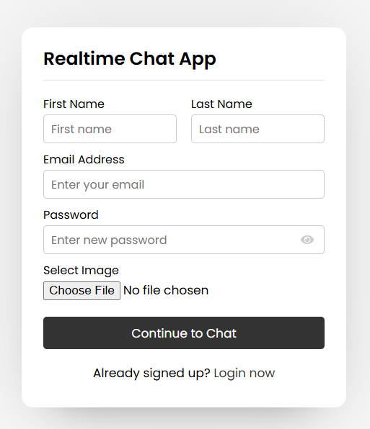

Figure 4.2: Add Student interface

**4.2.3 Login interface**

This interface is designed for authentication purposes, allowing only authorized users to gain access. Users must enter their credentials, such as a username and password, to log into the system.

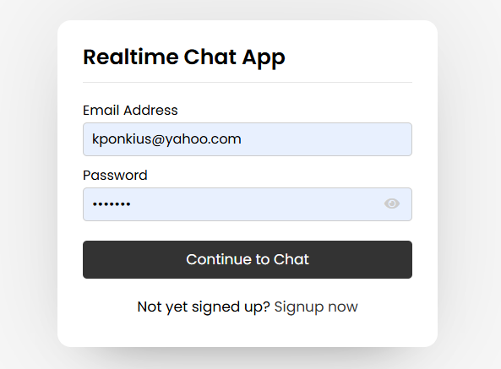

Figure 4.3: Login page interface

**4.2.4** **Available Users Interface**

The Available Users Interface displays a real-time list of all users currently online or registered on the platform. Each user is presented with basic information such as their name, profile picture, and status (online/offline).

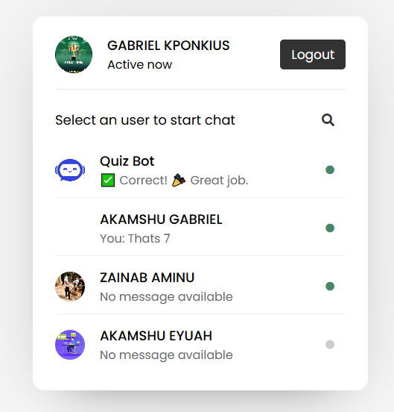

Figure 4.4: Available Users Interface

**4.2.5 Learning Mode Chat Interface**

The Learning Mode Chat Interface is a dedicated chat environment where structured academic discussions and collaborative learning take place.

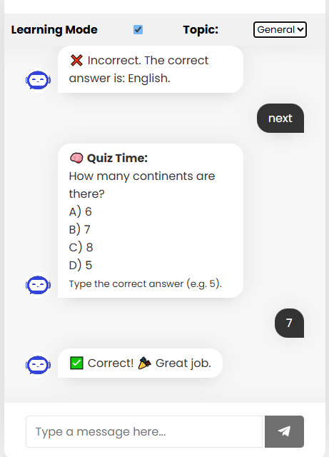

Figure 4.5: Learning Mode chat interface

## 4.3 Discussion

The Home Page Interface (Figure 4.1) is the entry point of the application and serves as the user's first contact with the system. It is designed with a clean, welcoming layout that reflects the purpose of the platform collaborative learning. Prominently displayed on the home page are the project title and researcher details, which provide context and credibility to the system. This interface often includes navigation buttons like "Register" and "Login," directing users to the appropriate next steps based on their access status. It is also aesthetically designed to create a user-friendly first impression and includes institutional branding or project-specific logos.

The Registration Interface (Figure 4.2) allows new users students or teachers—to create an account and join the learning platform. This form collects essential user information such as username, full name, email address, password, and possibly user role (e.g., student or teacher). The interface ensures data validation to prevent duplicate entries and maintains basic security practices like password masking and confirmation. Upon successful registration, users receive a confirmation and are redirected to the login page. This interface plays a crucial role in onboarding and ensuring that only verified users become part of the collaborative learning ecosystem.

The Login Interface (Figure 4.3) is a secured gateway into the application. It prompts existing users to enter their login credentials typically a username or email and a password. The authentication logic behind this interface checks user input against stored credentials in the system database. Only valid users are granted access to the application, ensuring the privacy and security of conversations and shared resources. Features like "Forgot Password?" and password visibility toggles may be integrated to enhance user experience. The login interface serves as a fundamental component in access control and user management.

The Available Users Interface (Figure 4.4) provides a real-time display of all users currently active or registered in the system. This interface facilitates social and academic interactions by allowing users to view others’ availability. Each user listed may include profile details such as name, role (student/teacher), profile picture, and online/offline status. A search bar and sorting/filter options are often included to help users find specific participants efficiently. Users can initiate a chat session by selecting a name from this list, making this interface central to peer-to-peer communication.

The Learning Mode Chat Interface (Figure 4.5) is the core of the collaborative platform. This interface supports real-time messaging within a structured, topic-based environment. It is designed to enable academic discourse between students and instructors. Key features may include: Text-based chats with rich formatting, Interactive tools such as quizzes, whiteboards, and file sharing. The interface fosters a sense of virtual classroom presence, allowing for enhanced engagement, live question-and-answer sessions, brainstorming, and feedback loops. It is also possible to host topic-specific rooms or breakout groups, further strengthening focused collaboration.

Each of the interfaces discussed above contributes to the overall effectiveness and intuitiveness of the collaborative learning platform: The Home, Registration, and Login interfaces streamline access and maintain system security. The Available Users Interface promotes community and peer engagement. The Learning Mode Chat Interface enhances interactive learning through modern digital tools.

## 4.4 User manual

## 4.4.1 System Installation

The user manual is a clear and precise instruction on how a user can operate the propose system, without any stress and successful. The following steps required

1. Start or boot the computer form the hard disk
2. Double click on the folder that program is been stored in the desktop
3. Double click on the program and allow it to load gently
4. A security unit will display were the user will specify the user name and password the click on OK.
5. A welcome menu will be displayed where the user has options to select which operation to be performed.
6. To find information about player, select any name and search.
7. Click on exist on the welcome screen to exist from the program.

## 4.4.2 System Operational Guide

The following are the necessary steps to take in order to use the system efficiently and effectively.

1. Load the url of the system <https://localhost/chatapp/> the welcome page will be displayed.
2. Click on the **Proceed** button to proceed to the main system.
3. Provide the login details by entering your username and password.
4. The various task that you can perform on the portal will be displayed on the sidebar of the dashboard.

# CHAPTER FIVE

# SUMMARY, CONCLUSION AND RECOMMENDATIONS

## 5.1 Summary

This research project focused on the design and implementation of a Collaborative Learning Chat Application with Interactive Tools aimed at enhancing communication, engagement, and collaboration among students and educators in an academic environment. The system was built to bridge the gap between traditional learning methods and modern digital learning by incorporating features such as real-time messaging, interactive learning modes, and user authentication. The methodology adopted in the design and development of the application. We utilized the waterfall model of software development, beginning with requirement gathering, followed by system design, implementation, testing, and deployment. We discussed the tools and technologies used such as PHP, MySQL, HTML, CSS, and JavaScript—to create a responsive and functional platform. The system implementation, results, and interface descriptions. Interfaces such as the Home Page, Registration Page, Login Page, Available Users Page, and the Learning Mode Chat Page were discussed. Screenshots and interface explanations demonstrated how the platform allows users to interact, register, and collaborate effectively using real-time tools.

## 5.2 Conclusion

In conclusion, this study successfully developed a Collaborative Learning Chat Application with Interactive Tools tailored for academic environments. The platform addresses the limitations of traditional learning methods by offering a system where users can register, log in, and collaborate in real-time using a structured chat system. The application promotes active participation, real-time interaction, resource sharing, and enhanced feedback mechanisms. By integrating key features such as user authentication, online user visibility, and dedicated chat spaces for academic discussions, the system contributes significantly to improving digital learning. It provides a cost-effective and scalable solution for institutions aiming to improve collaboration and engagement among students. The system was tested and evaluated, and it met the objectives set out at the beginning of the project. It is user-friendly, efficient, and adaptable to various educational levels.

## 5.3 Recommendations

Based on the development and evaluation of the system, the following recommendations are made:

1. Future versions should support the upload and sharing of multimedia files such as images, videos, and audio to improve engagement and learning diversity.
2. To increase accessibility, a mobile application version of the platform should be developed for Android and iOS devices.
3. Introducing AI-powered tutors or chatbots can provide automated responses to common queries and assist learners in real-time.
4. Security Enhancements: Implement stronger encryption and multi-factor authentication to improve the security and privacy of user data.
5. Adding badges, and leaderboards can help boost user motivation and enhance the learning experience.
6. As user demand increases, the system should be tested for scalability to ensure it can handle more concurrent users without degradation in performance.

**REFERENCES**

Al-Samarraie, H., & Saeed, N. (2018). A systematic review of cloud computing tools for collaborative learning: Opportunities and challenges. *Computers & Education, 124*, 77–91. https://doi.org/10.1016/j.compedu.2018.05.021

Anderson, T., & Dron, J. (2021). Three generations of distance education pedagogy. *International Review of Research in Open and Distributed Learning, 12*(3), 80–97. https://doi.org/10.19173/irrodl.v12i3.890

Basilaia, G., & Kvavadze, D. (2020). Transition to online education in schools during a SARS-CoV-2 coronavirus (COVID-19) pandemic in Georgia. *Pedagogical Research, 5*(4), 1–9. https://doi.org/10.29333/pr/7937

Bernard, R. M., Borokhovski, E., Schmid, R. F., Tamim, R. M., & Abrami, P. C. (2022). A meta-analysis of blended learning and technology use in higher education: From the general to the applied. *Journal of Computing in Higher Education, 34*(1), 149–187. https://doi.org/10.1007/s12528-021-09305-6

Brown, A., & Green, T. (2022). *The essentials of instructional design: Connecting fundamental principles with process and practice* (4th ed.). Routledge.

Crompton, H., Burke, D., & Gregory, K. (2021). The use of educational technology in higher education: A systematic review. *Educational Technology Research and Development, 69*(3), 1401–1424. https://doi.org/10.1007/s11423-021-10019-9

Dicheva, D., Dichev, C., Agre, G., & Angelova, G. (2022). Gamification in education: A systematic mapping study. *Educational Technology & Society, 22*(3), 75–88.

Dillenbourg, P. (2019). *Collaborative learning: Cognitive and computational approaches*. Elsevier.

Hamari, J., Shernoff, D. J., Rowe, E., Coller, B., Asbell-Clarke, J., & Edwards, T. (2021). Challenging games help students learn: An empirical study on engagement, flow, and immersion in game-based learning. *Computers in Human Behavior, 54*, 170–179. https://doi.org/10.1016/j.chb.2021.03.020

Hrastinski, S. (2021). What do we mean by collaborative learning? *International Review of Research in Open and Distributed Learning, 22*(2), 210–224. https://doi.org/10.19173/irrodl.v22i2.4914

Hwang, G. J. (2023). Definition, roles, and research trends of artificial intelligence in education. *Educational Technology & Society, 26*(1), 1–15.

Järvelä, S., Järvenoja, H., Malmberg, J., & Näykki, P. (2021). Exploring socially shared regulation in collaborative learning groups. *Metacognition and Learning, 16*(2), 335–365. https://doi.org/10.1007/s11409-021-09267-7

Kim, Y. J. (2023). Exploring the impact of collaborative learning technology on student engagement and achievement. *Journal of Educational Computing Research, 61*(1), 44–63. https://doi.org/10.1177/07356331221134322

Laudon, K. C., & Laudon, J. P. (2019). *Management information systems: Managing the digital firm* (16th ed.). Pearson.

López, D. M., Pérez, M. A., & Rodríguez, J. P. (2023). Virtual reality in education: Enhancing collaborative learning environments. *Journal of Computer-Assisted Learning, 39*(2), 190–206. https://doi.org/10.1111/jcal.12678

Luckin, R., Holmes, W., Griffiths, M., & Forcier, L. B. (2021). *Artificial intelligence and the future of learning*. Routledge.

Mayer, R. E. (2021). *Multimedia learning* (4th ed.). Cambridge University Press.

Oliver, M. (2024). *Innovations in online education: Strategies for collaborative learning*. Sage Publications.

Pressman, R. S., & Maxim, B. R. (2020). *Software engineering: A practitioner's approach* (9th ed.). McGraw-Hill.

Resnick, M. (2022). *Lifelong kindergarten: Cultivating creativity through projects, passion, peers, and play*. MIT Press.

Rosé, C. P., Wang, Y., Cui, Y., & Arastoopour Irgens, G. (2019). Supporting collaborative learning with conversational agents and AI. *Computers & Education, 140*, 103603. https://doi.org/10.1016/j.compedu.2019.103603

Salmon, G. (2023). *E-tivities: The key to active online learning* (3rd ed.). Routledge.

Tang, Y., Hew, K. F., & Chen, G. (2020). Student engagement in flipped classrooms: A meta-analysis of the effects of interactive tools and collaborative strategies. *Educational Research Review, 30*, 100339. https://doi.org/10.1016/j.edurev.2020.100339

Vygotsky, L. S. (1978). *Mind in society: The development of higher psychological processes*. Harvard University Press.

Xu, D., & Ouyang, F. (2022). Personalized learning in digital collaborative education: The role of AI and learning analytics. *Journal of Learning Analytics, 9*(1), 34–56. <https://doi.org/10.18608/jla.2022.6993>

# APPENDIX A

Home page interface



Registration Interface



Login interface



Available Users Interface



Learning Mode Chat Interface



# APPENDIX B

PROGRAM CODE

<?php

  session_start();

  if(isset($_SESSION['unique_id'])){

    header("location: users.php");

  }

?>

<?php include_once "header.php"; ?>

  <style>

        /* Pop-up Modal Styles */

.modal {

  display: none;

  position: fixed;

  z-index: 999;

  padding-top: 100px;

  left: 0; top: 0;

  width: 100%; height: 100%;

  overflow: auto;

  background-color: rgba(0,0,0,0.5);

}

.modal-content {

  background-color: #fff;

  margin: auto;

  padding: 30px;

  border: 1px solid #888;

  width: 80%;

  max-width: 900px;

  border-radius: 10px;

  text-align: center;

}

.modal-content h2 {

  margin-top: 0;

  color: #007bff;

}

.close {

  color: #aaa;

  float: right;

  font-size: 34px;

  font-weight: bold;

  cursor: pointer;

}

</style>

<body>

  <div class="wrapper">

  <!-- Pop-up Modal -->

<div id="aboutModal" class="modal">

  <div class="modal-content">

    <span class="close">&times;</span>

    <img src="php/images/FPMLOGO.png" alt="FPM Logo">

    <h2>CHAT APPLICATION FPM</h2>

    <h1>COLLABORATIVE LEARNING CHAT APPLICATION WITH INTERACTIVE TOOLS</h1>

    <br>

    <hr>

    <p>Designed by <strong>USAMA H. IMAM (ST/CS/HND/23/005)</strong></p>

  </div>

</div>

    <section class="form signup">

      <header>Realtime Chat App</header>

      <form action="#" method="POST" enctype="multipart/form-data" autocomplete="off">

        <div class="error-text"></div>

        <div class="name-details">

          <div class="field input">

            <label>First Name</label>

            <input type="text" name="fname" placeholder="First name" required>

          </div>

          <div class="field input">

            <label>Last Name</label>

            <input type="text" name="lname" placeholder="Last name" required>

          </div>

        </div>

        <div class="field input">

          <label>Email Address</label>

          <input type="text" name="email" placeholder="Enter your email" required>

        </div>

        <div class="field input">

          <label>Password</label>

          <input type="password" name="password" placeholder="Enter new password" required>

          <i class="fas fa-eye"></i>

        </div>

        <div class="field image">

          <label>Select Image</label>

          <input type="file" name="image" accept="image/x-png,image/gif,image/jpeg,image/jpg" required>

        </div>

        <div class="field button">

          <input type="submit" name="submit" value="Continue to Chat">

        </div>

      </form>

      <div class="link">Already signed up? <a href="login.php">Login now</a></div>

    </section>

  </div>

<!-- Add jQuery before your script -->

<script src="https://code.jquery.com/jquery-3.6.0.min.js"></script>

<script>

  $(document).ready(function(){

    var modal = $("#aboutModal");

    // Automatically show the modal when the page loads

    modal.show();

    // Close modal when 'X' is clicked

    $(".close").click(function(){

      modal.hide();

    });

    // Close modal when clicking outside the modal content

    $(window).click(function(e){

      if ($(e.target).is(modal)) {

        modal.hide();

      }

    });

  });

</script>

  <script src="javascript/pass-show-hide.js"></script>

  <script src="javascript/signup.js"></script>

</body>

</html>